Week 7: SQL Query Implementation for E-Commerce Database
Scenario:
An online shopping company maintains information about customers, products, orders, payments, and inventory in its database. The management team wants to analyse customer purchases, monitor product availability, and track order details for smooth business operations.
Students will use SQL queries to retrieve, filter, sort, and analyse data and generate useful business reports from the existing online shopping database.
Perform Basic SQL Queries Concept:
SQL SELECT command is used to retrieve data from database tables.
Display all customer details
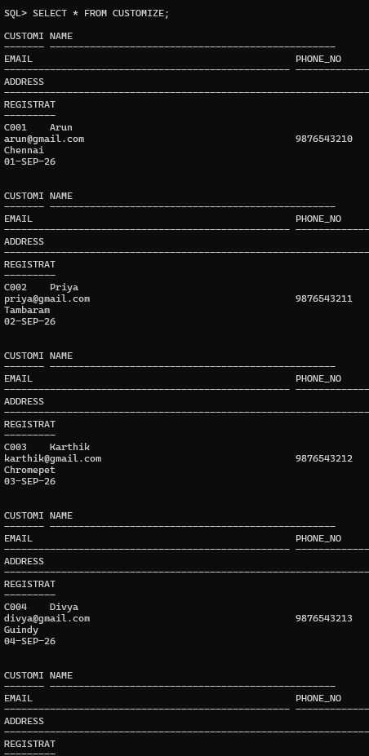

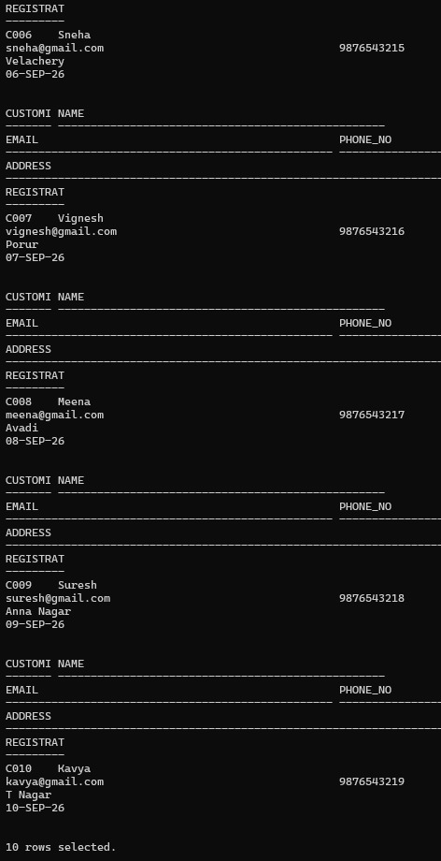

Display all available products.
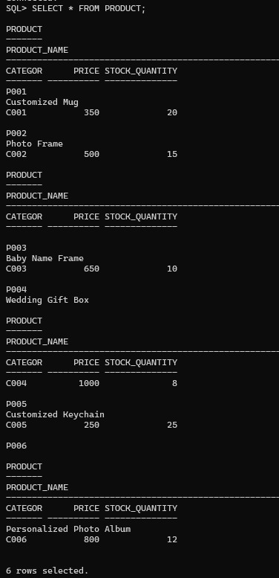
Retrieve product names and prices only.
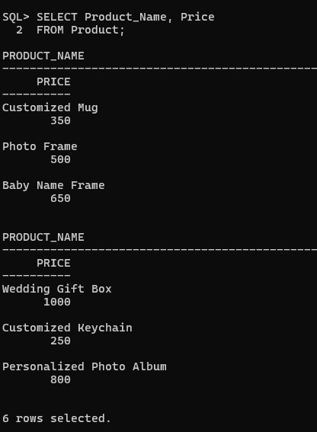

Display all orders placed by customers.

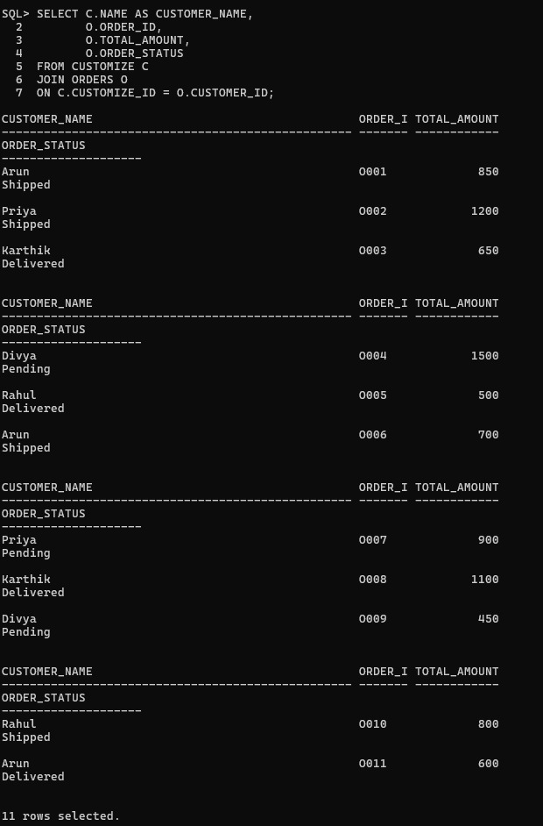

Retrieve payment details.
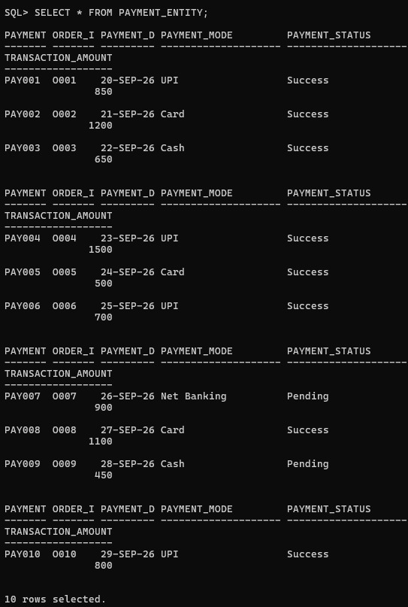

2. Apply Filtering Conditions Using WHERE
Find products with price greater than ₹5000.
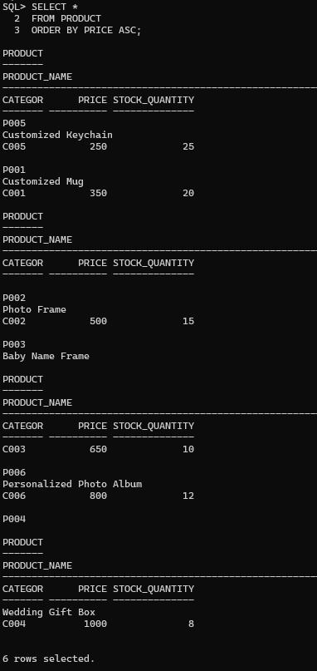

Display products available in stock.
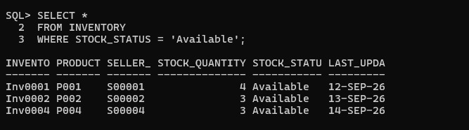
Display completed orders. 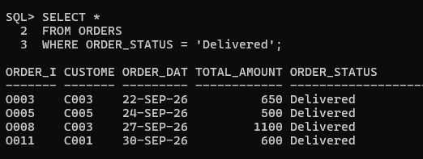
Find products with rating above 4.
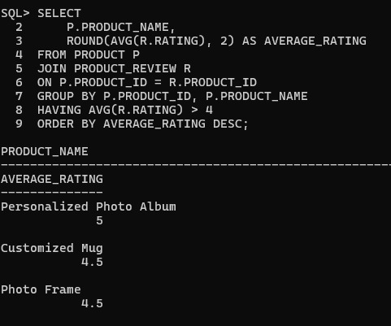

3.Sort Data Using ORDER BY Tasks:
Display products from lowest to highest price.
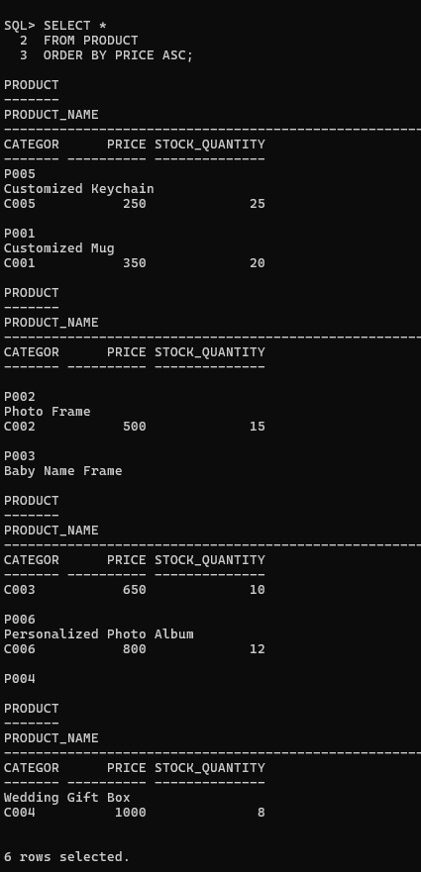

Display customers alphabetically
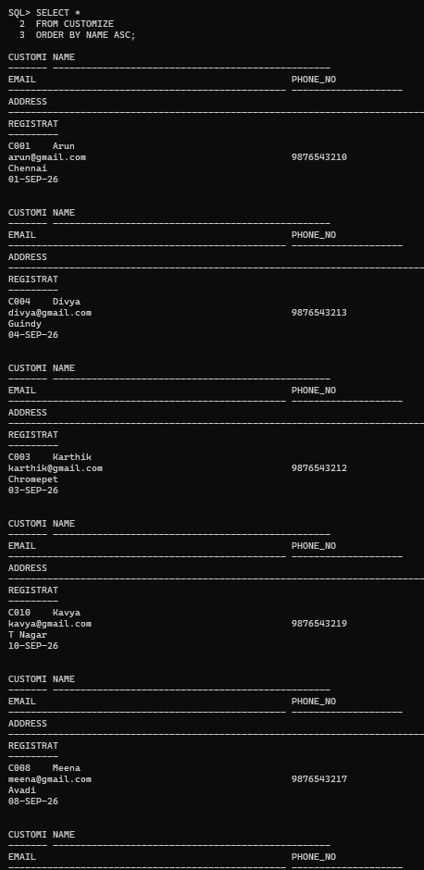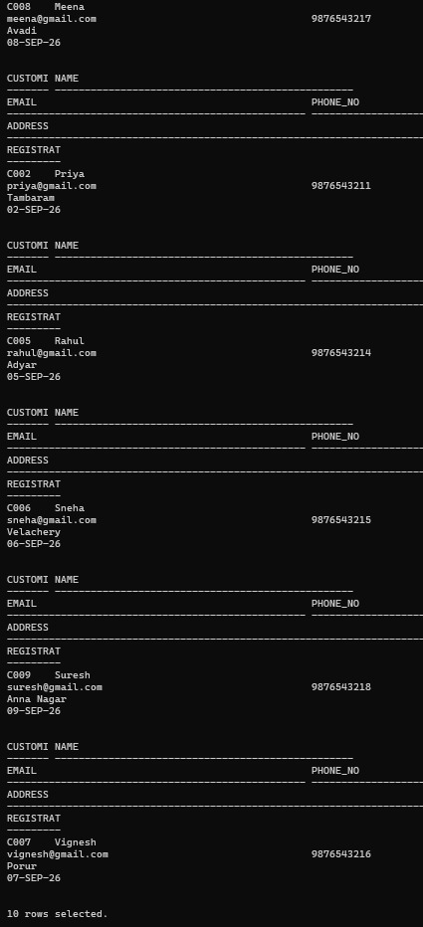

Find top expensive products
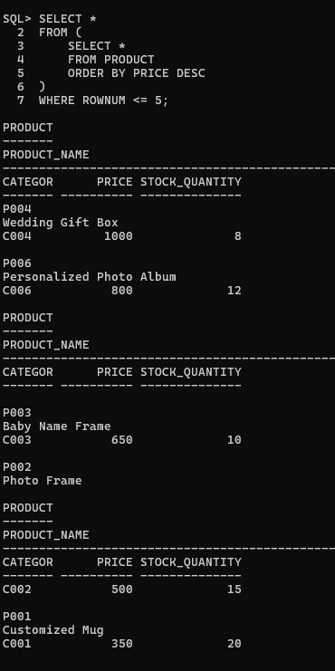
Display latest orders first
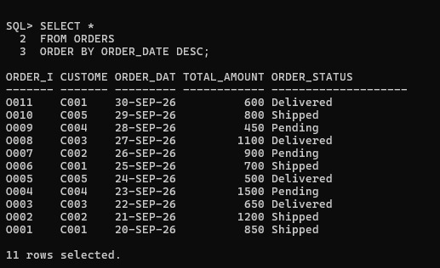

4.Retrieve Unique Values Using DISTINCT
Display unique product categories.
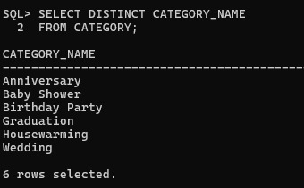
Find different payment methods used by customers. 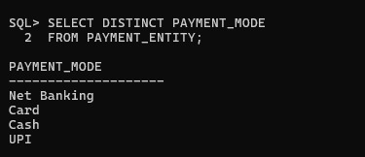

5.Search Products Based on Conditions
Write SQL queries to:
Display products belonging to a particular category.

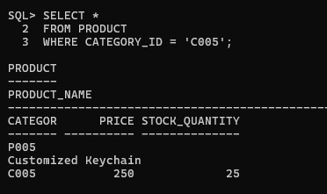

Find products currently available in inventory. 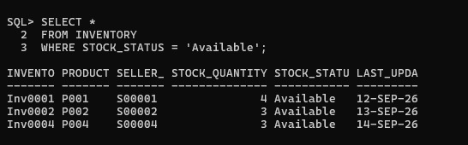
Search products using product name.
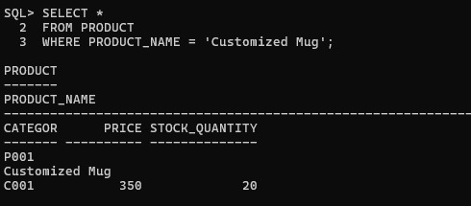
Find low-stock products
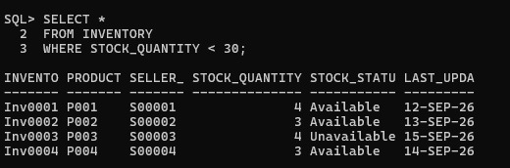
6.Retrieve Customer and Product
Display customer details with their orders.
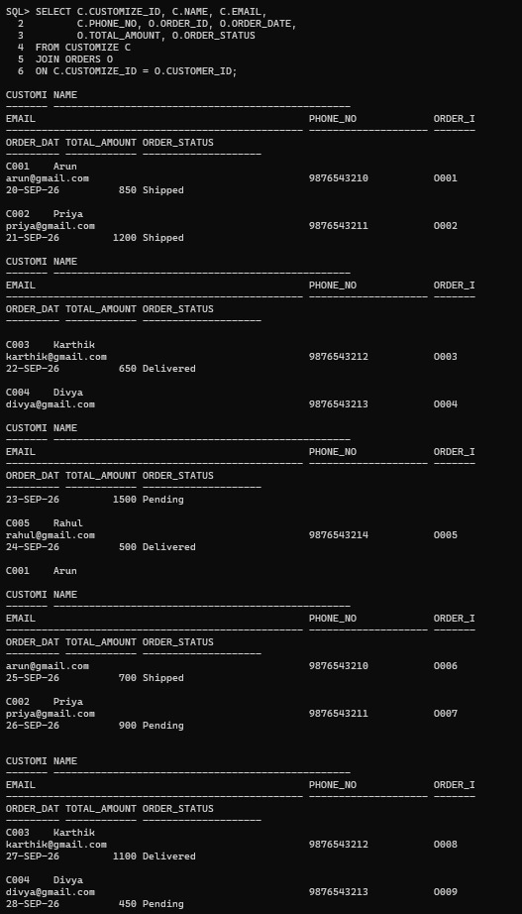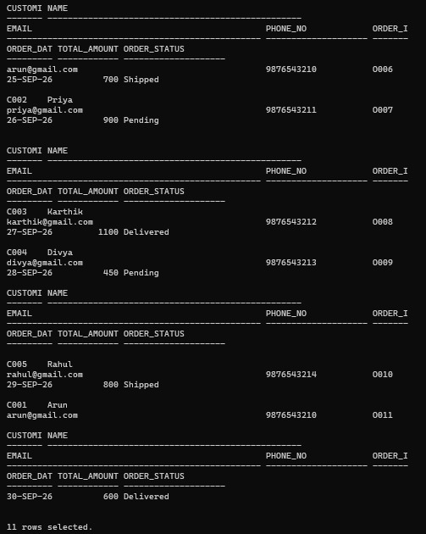

Display product details with category information
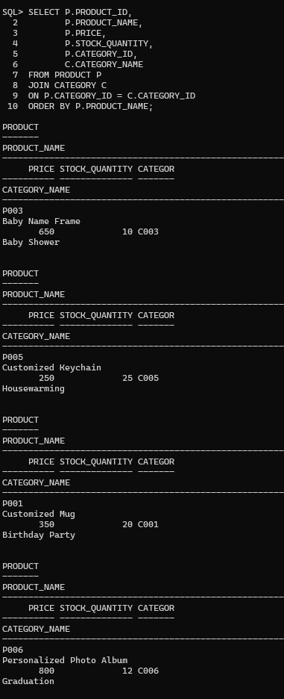
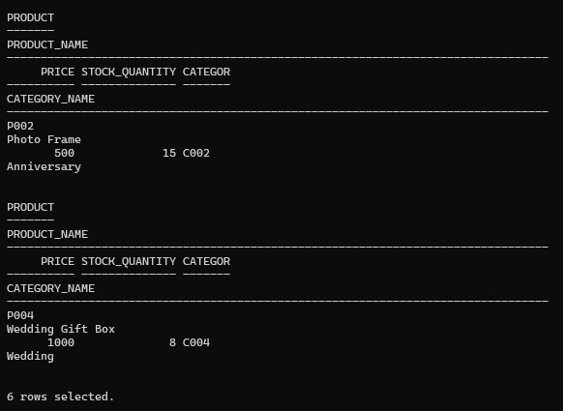
Find customers who purchased a specific product. 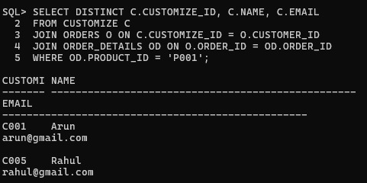
Display products purchased by each customer.
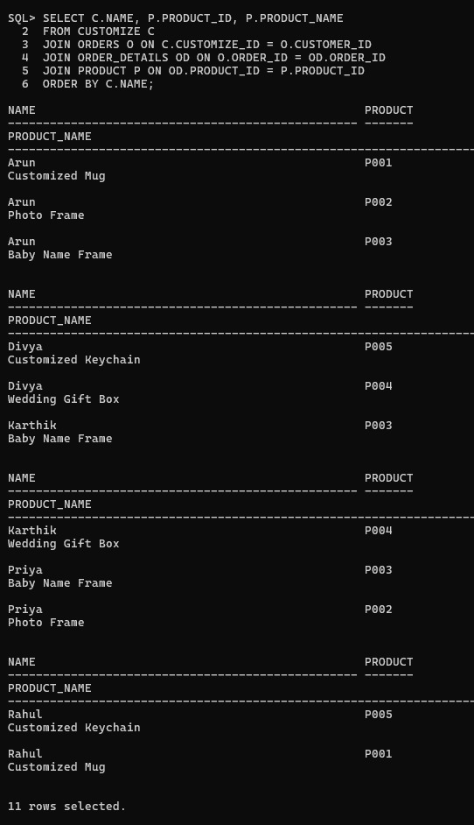
7.Apply Multiple Filtering Conditions
Find electronics products costing more than ₹1000
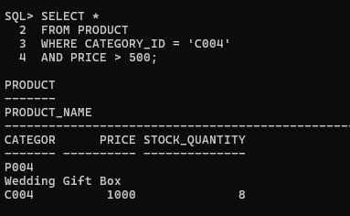
Search products containing the word "Mobile".
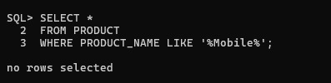
Find orders placed within a specific date range.
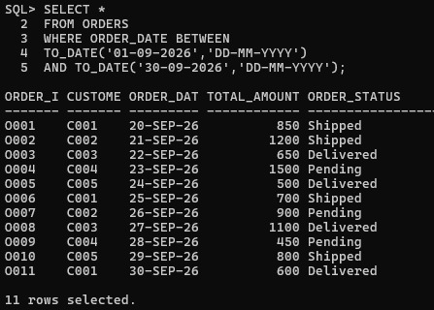

8.Generate Basic Business Reports Report
Product Availability Report Display:
  - Product name
  - Price
  - Stock quantity
  - Availability status
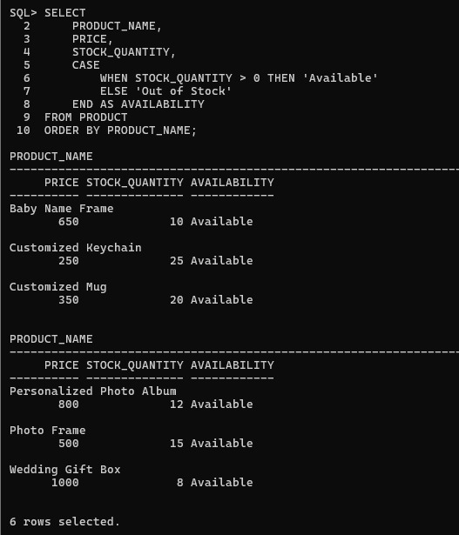

Customer Report Generate:
- Total number of customers
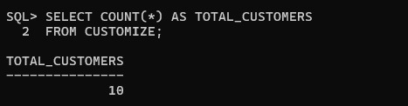
- New customer registrations
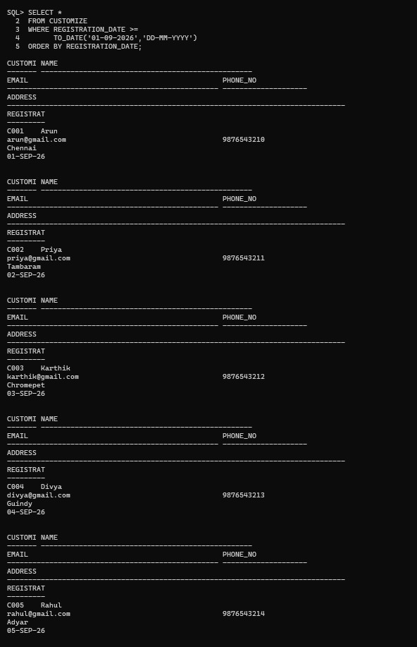
Order Report Display:
- Total orders
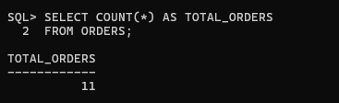
- Completed orders
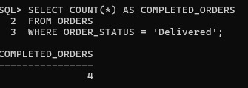
- Pending orders
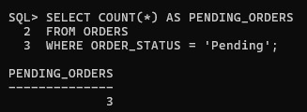
- Cancelled orders
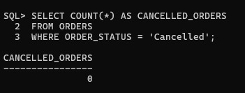

Product Performance Report
Find:
- Highest-priced products
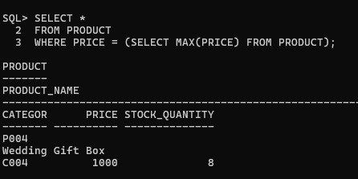
- Most reviewed products
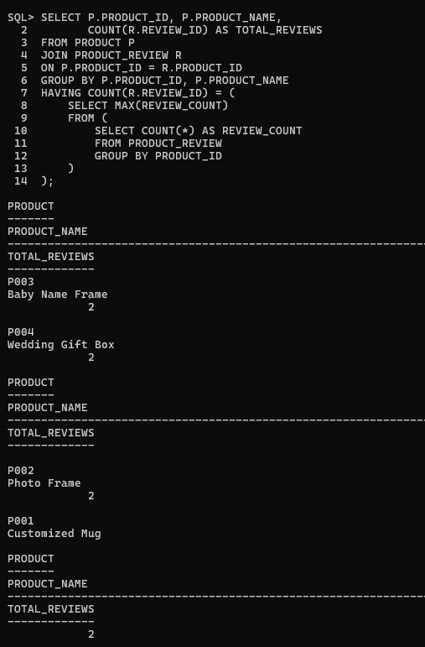

- Available products
